**Idea Document**

This is an open place to share your ideas for the group to see and discuss

(Add categories as needed)

**Structure Ideas and Considerations:**

|  |
| --- |
| Underneath this box you can jot down thoughts you may have regarding how you feel the game could be structured, which is a topic we’ll be discussing during our Monday meeting . Structure in this case particularly pertains to the game world, progression and scope .  What you write here doesn’t need to follow any structure, but here are some questions one could consider: Do you picture a linear game, or one with branching paths? Does the player unlock skills/new notes? How do you imagine the music could be linked to the game’s structure and progression? What do you consider feasible in terms of scope?  You can put text, drawings, music or anything you feel helps you convey your thoughts here. Perhaps just leave some space between entries so it’s easy to distinguish between them.  If someone’s entry gives you an idea, or if you’d like to point out a thought or question it gives you, then you could potentially add a note to their entry In a different text colour. |

**Mark**: In short, find your way through the dungeon by interacting with the musical systems and solving the puzzles through them. Direction is not linear since player must find information on puzzles in different areas. Player can gather up to 8 tones (major/minor scale). Order of obtaining tones is also not linear which influences the music you are able to play throughout the levels. Even for a beginner, starting with two or three tones should be easy enough to engage with. Player must obtain all tones to be able to win. Playing music through the system does not allow same virtuosity as a piano or even your own voice, but should be fun and creative when certain sequences and combinations influence the world parameters.

We should compare musical modes when we want to decide, but I believe committing to a set scale allows for greater creative range since it makes it easier for player to play a melody. This would necessitate 8 tones.

B Harmonic Minor: Sad and gloomy

* <https://drive.google.com/file/d/1U-exRp07RNXz7TMa1J56lUxfB1eL2zoI/view?usp=sharing>

F Major: Optimistic

* <https://drive.google.com/file/d/1ulxcWMyvkQv-OyOE5O6JgWuM0u3ucQog/view?usp=sharing>

**Magnus**: Here is just a very rough draft of how one potential structure/map of the game could look. I like the idea of lower/higher levels that changes background music and requires the player to be quiet/loud. What I’ve detailed here is only the “critical path” - there could be dozens of optional or hidden passages.

Some things I should have made more obvious:

START: Middle left box.

ROUND BOXES: Means there could be any number of consecutive rooms with different challenges.

GREY, DARK, BLUE: Denotes starting area, the dark levels, and the higher, more ethereal levels, respectively.

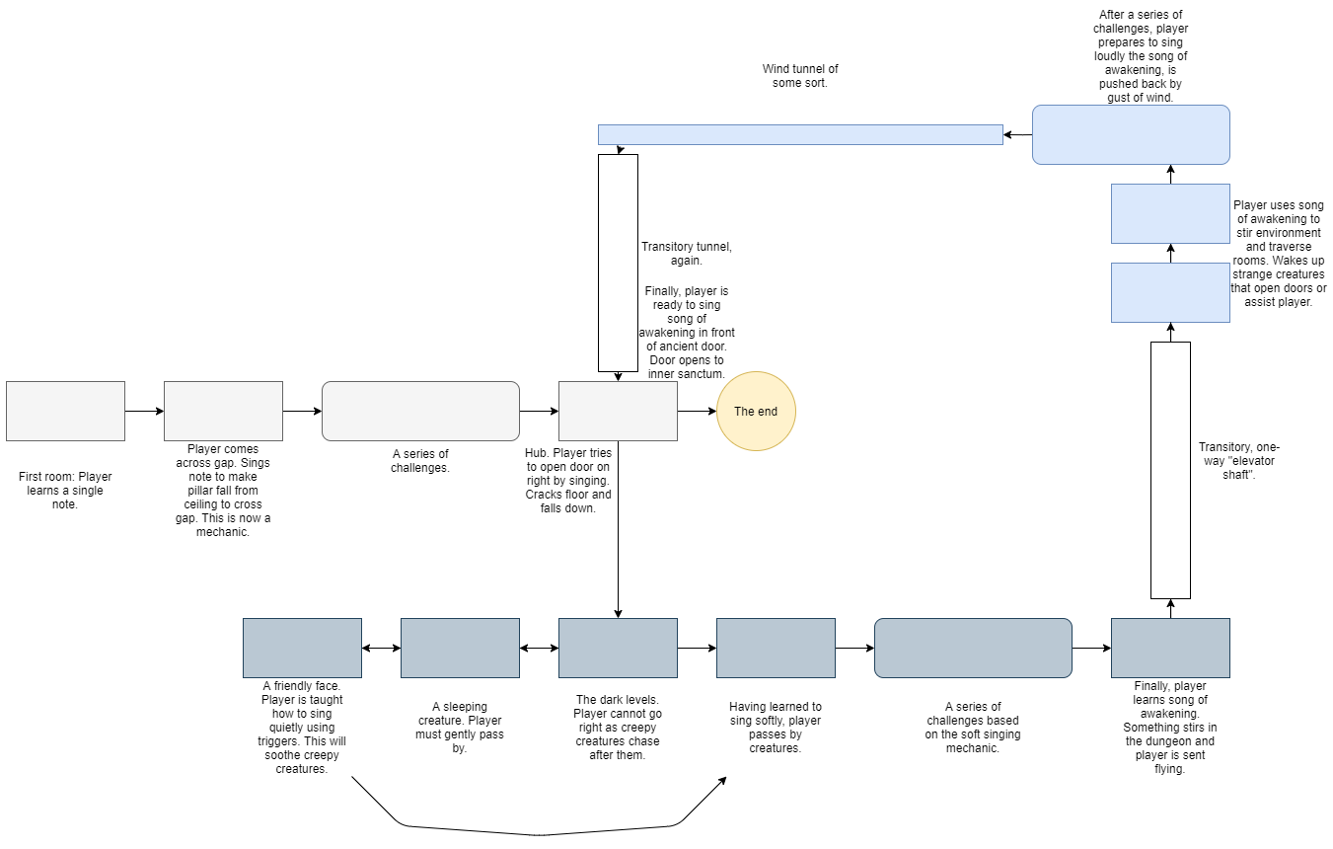

**Martin:**

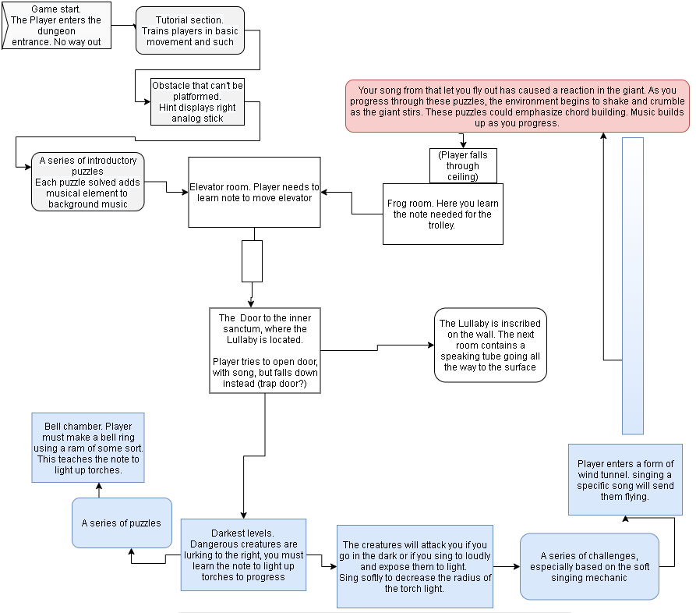

**Gameplay Ideas**

**Marcus:** Changing the tempo of the music, changes the speed of the world, like the speed of a moving platform. Could set the tempo by a player having to hit a tempo (BPM) on a keypress.

**Martin:** Pressing the analog stick: activate metronome? Is it too hard to press it?

**Johnny:** The game can be a Metroidvania – you unlock skills throughout the game, which you can use to progress further into the dungeon.

**Magnus: “**Causing avalanches, earthquakes, soothing things, scaring others, etc. Or being able to dynamically change the background music through song. Like an arpeggiator(?) whose root tone or chord can be influenced, which may change the mood of the world. Or maybe it allows you to jump between different parallel layers of the same world (one is Major and upbeat, one is Minor and sad). I guess the "risk" is that the music/sounds could have been something else instead, like colors or abstract symbols. Like in the case of Zelda where music is of profound importance to the world, story, and overall message of the game but has no real systemic qualities in the game itself. **That's why I really liked Mark's idea of emphasizing the unique expressive abilities (however lackluster) of the player, rather than "filling in the blanks."”**

**Johnny:** Maybe different skills could be power-ups – higher jumps, larger size, bigger voice range?

**Loom** - gain the ability of the owl by singing its song - you meet an owl in Loom, it has a song. And if you play their song in a dark room, then you will become able to see in The dark, like the owl.

**Marcus:** Objects indicating what note sequence they need: Marcus had the idea that some items could have greyed out notes, corresponding to the amount of notes the object needs for the interaction. Then when you sing the correct note, the grey notes will get filled out, but not linearly, instead each correct note will go in its proper place in the arrangement. An addition I would suggest: the

Grey notes only appear when you have sung, then they slowly fade out again. Maybe the grey notes reset after a little while, in case you’re not actually trying to manipulate the object at the time.

**Mark:** Ability to influence the musical motif of the world – “You can also consider inverting the motif, if the melody is "going upwards" from a tone, repeat that tone but have it "go downwards" using the same distance between tones as the one going upwards.”

**Martin: “**I wonder if it's possible to use something like the main trigger on a controller to control how intensely/loudly you sing, and how that could be incorporated into the game”

**Magnus: “**I think using the pitch or amplitude of sounds/notes to influence the behavior of the world would be super interesting. Like shattering glass with a high note or sending waves through water or making jelly walls shake or deafening enemies or, or, or.”

**Martin:** “Maybe you can tie the velocity of the notes to the trigger of the controller? Maybe you would run out of breath at some point, but your song would have a larger range and influence.”

**Everyone:** The game must let the player be expressive and use the music in a fun way.

**Martin:** Maybe touching or holding an object lets you hear it’s song – you can then evoke the object through singing… Perhaps you encounter some animals or frogs at some point in the game – you learn to imitate their croaks, and thus learn a new tone.

**Fer:** Echo as mechanic: make a chord through echo while still having just one note playing. That is also kind of unique to a music puzzle game. You have seen levitation in other games where you just use a magical wand, but with echo effect you need to make sounds.

**Unattributed:** A dynamic, discrete camera, like Celeste. Composing the world through sound, like making a flame flicker or fade with noise/voice

By pressing R2 or L2 without choosing a note, our hero will still display the animations for singing. Thus you can make it look really goofy and funny on the go at all times. It is part of his expressive body language (think of Sackboy). This also emphasizes that there is no set order of actions for performing a tone. While pressing R2/L2 you can still choose a tone and then promptly make sounds. Although in many cases you will probably likely want to first choose tone on the wheel and then intonate.

It could be made possible for fast switching between tones in order to achieve a musical toy capable of more free interaction with the music and not hindered by controls so you only end up with melodies of long notes and little rhythmic variation.

When playing a chord, click to save it in some sort of temporary bank and have it replayed on the go when you choose so. You can then put together a musical period of maybe 2 or 3 chords to repeat and then proceed to play small melodies over it.

* A consideration I’ve had relating to this point; perhaps the note(s) you “hold” with the hold mechanic should remain available whenever you press the sing button, instead of disappearing one you let go of the hold button. This would let you keep a select note/chord ready-to-hand, until you choose to replace it.

- Singing a “rising” chord makes things move upwards. Singing a “descending” chord makes them fall to the ground.

**Johnny:** I envision two different ways for the players input to be sent to the interactable objects around him. The first approach is the one we are doing for the prototype, where the player starts singing and chooses the different notes (either before starting to sing, or during singing), and then once the UI-section corresponding to the selected notes are all full, the player will send a single data-object to the surrounding interactable objects that it has registered. In this approach the data is send at a single distinct time, and it makes it possible to make puzzles where objects requires sequences of notes/coords (a sequence like: A -> C -> BC -> A). Some of thes problems with this one, is that the data is only sent once, but what if the player continues singing, and there are some complex timing considerations to consider (like once a part of the sequence has been inputted, should the object then resets the sequence if nothing has been sung for a couple of seconds?).  
This first approach I would call discrete singing, as the game itself only registers the singing at singular discrete moments.

Another approach would be continuous singing, where as long as the player holds a note on the note-wheel, it will send a signal containing that note to surrounding objects. The interactable objects would then instead need to be made to register this continuous singing, and an example of accepted input to an object could then be: A(0.5s), B(1s), C(0.5s), so where the player needs to sing these three notes at the same time, but for different durations.  
Some really good things about this approach, is that it simplifies timing, as objects just receives input at every frame singing happens instead of on a single frame; it gives a more clear connection between singing and interacting with objects; it is simpler to visualize (again due to timing of UI-responses); we eliminate the problem of combinatorial explosion, so we could have more notes in the game (with the discrete approach, we need to write code and maybe make sprite assets, for every single combination, but with continuous we only need code for every note, and maybe a sprite asset for every note).  
With continuous singing, it is even still possible to make sequences of notes/choords to interact with certain objects, we just need to have several objects activate each other in a serie instead of having the sequence on the actual object we want to interact with.

**Martin: Tweaking the hold mechanic:** Perhaps when you let go of the hold button, it doesn’t erase the note you held. This would allow players to sing a desired note with only a trigger pull, rather than them having to use the wheel or hold down the “hold” button continuously. This could be useful for instances where a player just wants to sing the same note multiple times in one level, without having to press several inputs.

In this scenario, pressing the hold button would, in addition to its current functions, also override the last held note, letting the player continuously define which note they want quick access to. or..  
**Perhaps the last note you sung is always ready to be played with the triggers?**

This is meant to address a potential issue of the user finding the button inputs needed to be overwhelming, but I suppose we need to test if this issue comes up in the first place.

**Martin:** When entering a level, interactable objects initially appear as regular objects, however, when you sing a note, they will shine with their respective aura.

**Story/World Ideas**

A tapestry shows the world’s past. What happened? Did an ancient civilization vanish? Why is everything so gloomy?

**Martin:** Perhaps some dungeon backgrounds could have holes that expose things deeper into the background.

**Mark:** In the old times, a guild of artists and scholars considered the best and brightest at the time once discovered they could harness the energies and forces of this world through music.

**Mark:** While music can influence the physics of the world in our case (opening doors and making platforms move), it is certainly always the case that music is an exchange between people or an exchange with oneself if playing. You perform music freely and playfully on your own rehearsing, improvising or perhaps composing a tune; you perform music adeptly and responsibly along with others making sure to hone your technique and support the group effort; as a constant member of the audience you listen intently and openly both to yourself playing as well as others - you think your experience of music may be your own, but remember this is also the case for other people; you delight in working your *craft*, helping others and helping yourself through it. If music can be played to heal others in our world for example, it should certainly also be able to heal the restless soul of the one playing, because the act is in itself simply delightful. Like play: an activity with no value to be gained besides the creative delight itself.

**Martin:** Maybe towards the end the world is beginning to shake more and the sounds of falling rocks can be heard as rocks fall in the foreground. When you sing the lullaby, the sounds of the falling rocks fade as all goes quiet. The musical motif of the lullaby echoes upwards through the dungeon. The music carries on as the camera moves upward through the dungeon

**Musical Ideas**

**Martin:** Let the events of the world be represented in the music - for example - the dripping water drops of stalactite May fall into a small pool of water, each drip in the water is incorporated into the music, can be slowed down

**Marcus: Vertical Mixing** – rather than shifting between songs on every level, consider instead mixing and swapping out different instruments in order to suit the mood of the level more. “Various versions of the same base song”

**Mark:** You assign musical motifs yourself in the beginning of the game – can be configured later. These motifs can serve specific functions. Not bound to rhythm or such. **The world speaks to the player through motifs –** Maybe the player has to adjust their motifs in order to engage with the world properly.

**Mark:** Intonation button is either R2 or L2. There could be a distinction between just tapping and holding the button. This distinction is in musical terms known as *staccato* and *legato*, respectively. By tapping quickly and letting go, the tone(s) will be played and cut off almost immediately afterwards. By holding in the player will instead play legato, which simply means the tone will not be as abruptly cut when lifting the button again. Legato hold is distinguished from a staccato tap only by pressing the button for a tad bit longer than staccato or holding it in for a long time.

Mark: the developing background soundtrack is the Lullaby. Instrumentation may be a harp

**Level Ideas**

**Martin:** Imagine a puzzle - you need to sing to the door to open it, but it doesn’t have a clear sequence it wants you to pull, so you experiment singing different notes to it - it opens slowly, then it may stop, until you find the next note or velocity or whatever to make it open the rest of the way.

**Magnus:** With the sound/color wheel becoming a core mechanic, we could have Simon Says-esque sequences of recognition and imitation.

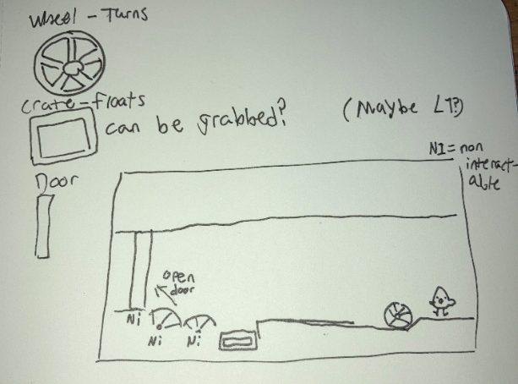

**Mark:** In large rooms, the camera will pan out to display the smallness of our hero. However, once the character starts to sing, the echo of sound will be so loud it will cause falling debris, huge blocks of stone, which can then allow passage across a large empty gap for example.

**Marcus:** a level where you have to find the correct note to play to lure an animal on top of a pressure plate to open a door for you. Trick here would be that you are scaring the animal away if you sing too loud, so the R2 only needs to be maybe 25%-50% pressed down. - Cool!

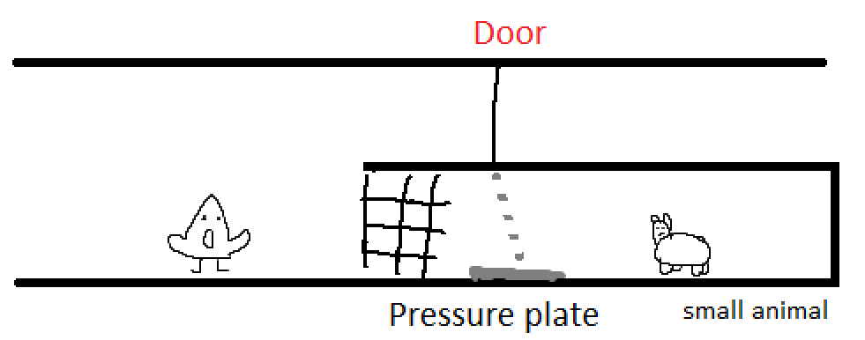

**Mark**: The windpipe listener. A curious contraption, perhaps a toy, found in some places within the dungeon. It seems mechanical in nature and it relies on musical artifice, knowledge of sounds. It is a passing mechanism that may unlock further progress by receiving the correct input. The player will input two tones at the same time (G, B) to which the windpipe listener will operate and put out the third tone that makes out a standard chord (In G major that would be D tone). The windpipe listener will sustain that chord allowing the player to choose new combinations of tones. For the mechanism to be “solved” and allowing progress, player will have to play combinations of two tones in an order that makes the windpipe listener create a chord by itself. Player will thus have to deduct which tones are included in which combinations. Making the windpipe listener play the wrong tone will necessitate the player start from the beginning. Imagine then placing a second windpipe listener in the same room where the player must now deduct the right combination for both of them.

Mark: “[about Fluffy] Just play a bit of music and he falls straight asleep... I shouldn't have told you that!“

Navigating a longer hallway in one of the dark cavernous areas of the map, the player encounters a beast. The player must play a soothing, soft lullaby while navigating the area which of course contains some obstacles. The intent is for the player to *always* play *something*, remembering to change tone once in a while, and playing it softly while trying to navigate the room itself. The melody may be pretty bland and nonsensical, but that doesn’t matter. Lull the beast to sleep.

Mark: Three puzzles using chords

1. 

To add, this is a “power-up” once you have the three notes that form the chord G. In the same sense that you can lift platform using one tone, a chord (of any size) may make two or more things perform a singular action

1. 

It is about learning the tone-relationship between the activated platforms and deducting the right path. It also sounds musical when played (a little bit like a cadence)

* When playing any tone or combination of them, the single tone may block another tone from being played next until the activation toggle is flipped back.

*Sustain the bridge:*

In another puzzle, each individual tone and combination activates their own magical artifact that constructs a piece of a bridge. The objective is to cross the bridge by activating the right order of artifacts. Playing a tone or combination of tones works as a toggle that activates the artifact. This toggle is flicked back again when playing a new tone . If a player combines two tones, the combined tones will be able to activate a new artifact - for example A activates “A”, B activates “B” and A+B activates “AB” as long as they are sustained. It should be possible to determine whether “AB” stops both “A” and “B” from being active or not despite tones A+B both being played. It may differ from each instantiation of the puzzle.

* Function to be implemented: when playing any tone or combination of them, the single tone may block another tone from being played next until the activation toggle is flipped back.



1. 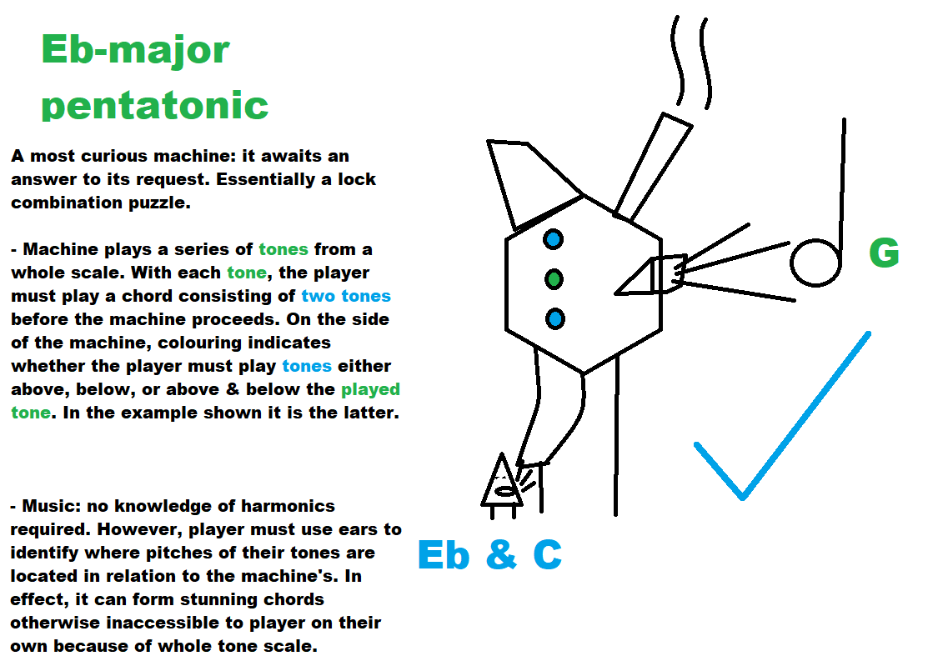
   1. 

*Lock combination*:

Tone is emitted from object in environment. Player must play two tones needing to either be: 1) lower, 2) higher or 3) lower & higher than tone from environment.

In one puzzle, a machine plays a first tone (using same tones as player for now).

* The player must respond by playing two tones at the same time. Those two tones can be signaled by the puzzle machine having to be either: 1) lower, 2) higher or 3) lower & higher than pitch from the first tone.
* Important that this is not volume but pitch of tone. As such, the game does not care about which tones the player picks, how loud or soft they are played, but cares about if the tone is lower or higher than the first tone.
* Ideally, the puzzle will play out as a series of those: a first tone and responding two tones, a first tone and responding two tones, a first tone and responding two tones, and then win.

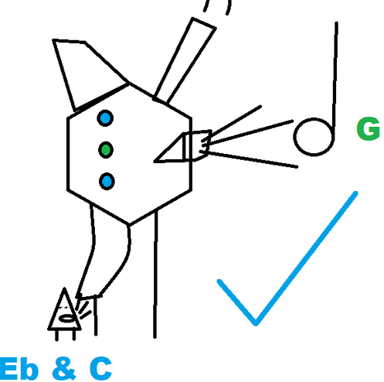

*In above picture, this ugly looking machine plays a first tone and expect a 3) lower & higher tone from player. This is indicated to the player on the side of the machine*.

Inspector features for puzzle:

* setting length of series, e.g. 1, 2, 3 before the puzzle is completed
* setting first tone on machine (also random) for each instance in the series

1. 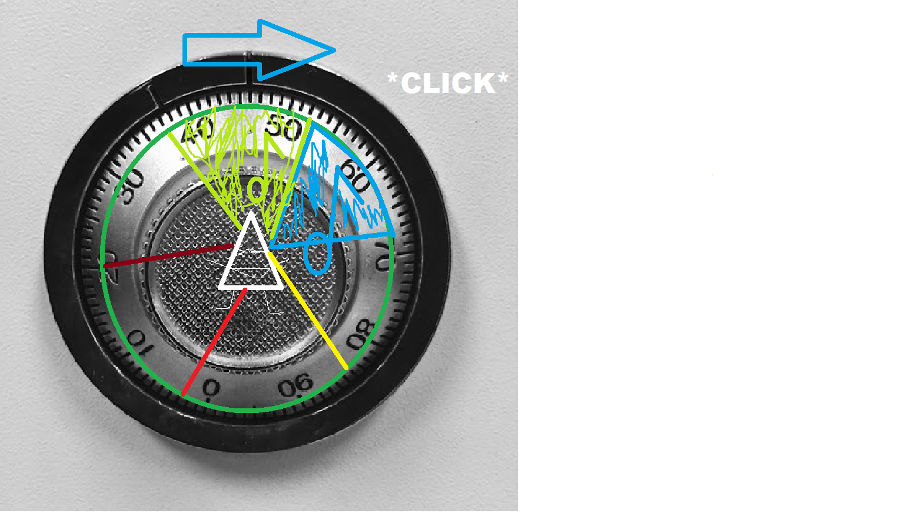

Open the lock by using the wheel and your ears. Your tone must match the one being played in the environment and you will have to move up and down the scale / wheel to reach the matching tone

1. 
2. 

Puzzle idé:

* Akkord er også at køre to toner på samme tid med dertilhørende puzzle effekt. Lifting yourself up using one tone and then choosing another tone to move an object underneath the first object to then stack.

**Puzzle Description List**

Underlying requirements for puzzles:

* Make use of existing or easy to implement systems tech have already put in place
* Cohesion and transferability
* Level progression and order/sequence of puzzles
* Tutorial: one tone and a jump, descending elevator
* Føl rummet for at igangsætte aura: scannerfunktion
* Bank til at beholde sidste spillede lyd
* Spil akkord, toner er gemt i afspilning men ikke i hjulet når du genoptager den og overskriver
* Filter og farver
* Adaptive soundtrack

**Tutorial**

* Gå til venstre og højre, hoppe over med box puzzle. Info om controls leveres i små soundbytes af “Kæmpen” eller diegetisk tegnet in-game tutorial. Soundbytes kan være melodiske af natur.
* Elevatoren går ned

**Puzzle misc. tanker**

* Rytme som puzzle parameter
* Grene
  + Melodiske sekvenser: lær at spille over tid
  + Akkorder: udtænk en sammensætning
  + Trykføler: leg med fysikken
    - Fasthold boks med trykføler over tid
    - Flappy Bird sekvens

Pressure sensitivity:

* Long / short: repel/attract
* Long hallway: keep light going, not too loud
* Turning wheels: lower / increase rhythmn to get timing right
* Flappy Bird:
* Opposition: scream breaks mirror / whisper keeps you alive

Chords:

* Chord sustain bridge:
* Chord building machine: it plays one tone, you play two. Simon says: it gives you G, you listen your way to choose next tones

Melodic sequence: stor fed fucking streg under tid

* Pump flyvende platform: frem og tilbage. Du spiller en sekvens af melodi, hvis du stopper så bevæger den sig bagud. Det skal gå lidt stærkt.
* Gangbro: først luk og så åbn op og gå ned
* Russisk roulette med hjulet